**Guideline for Customer interface**

1. New guest can register as customer by filling the required fields in register form.

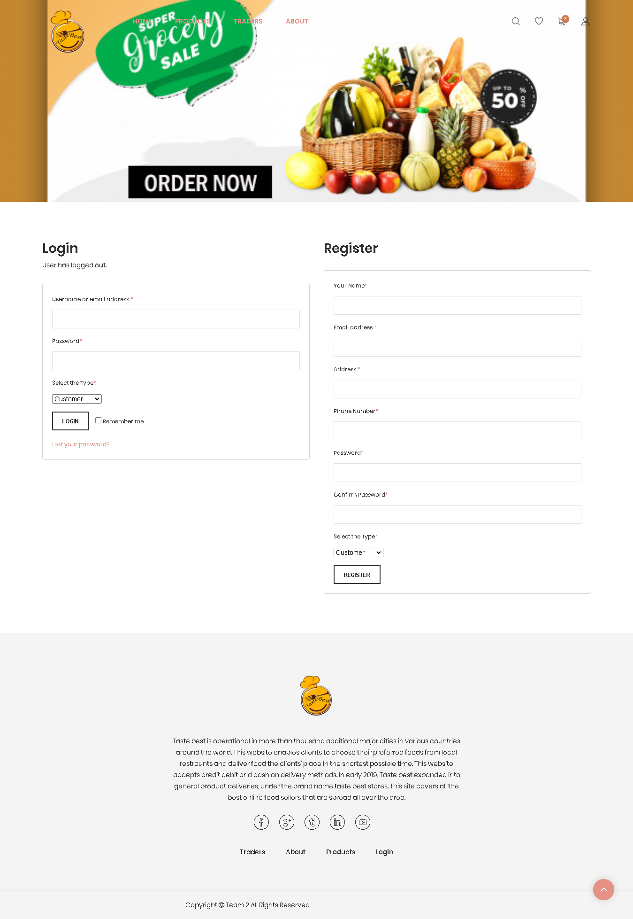

1. Customer will receive OTP in email after email verification and then applying valid OTP code person will be verified as a customer.

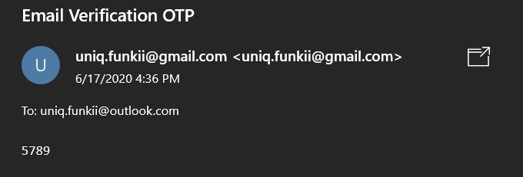

1. After valid registration customer can log in with their username or email address and password.

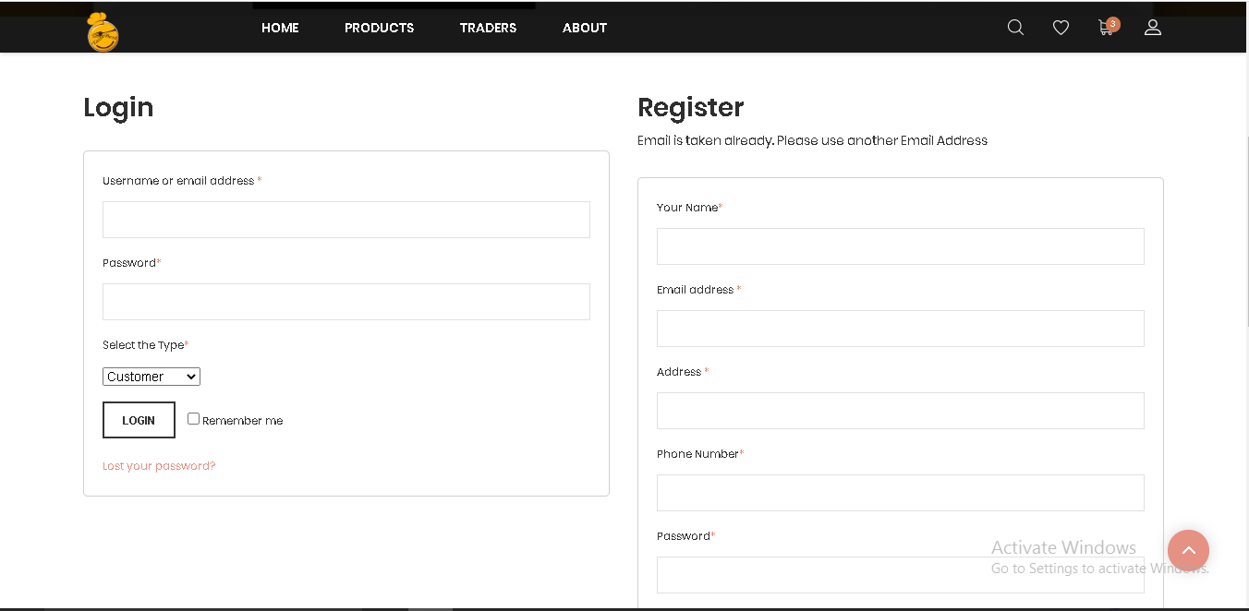

1. Incase customer forget their password , customer can reset it by clicking on ‘Lost your password?’ where OTP will be sent in customer email with password.

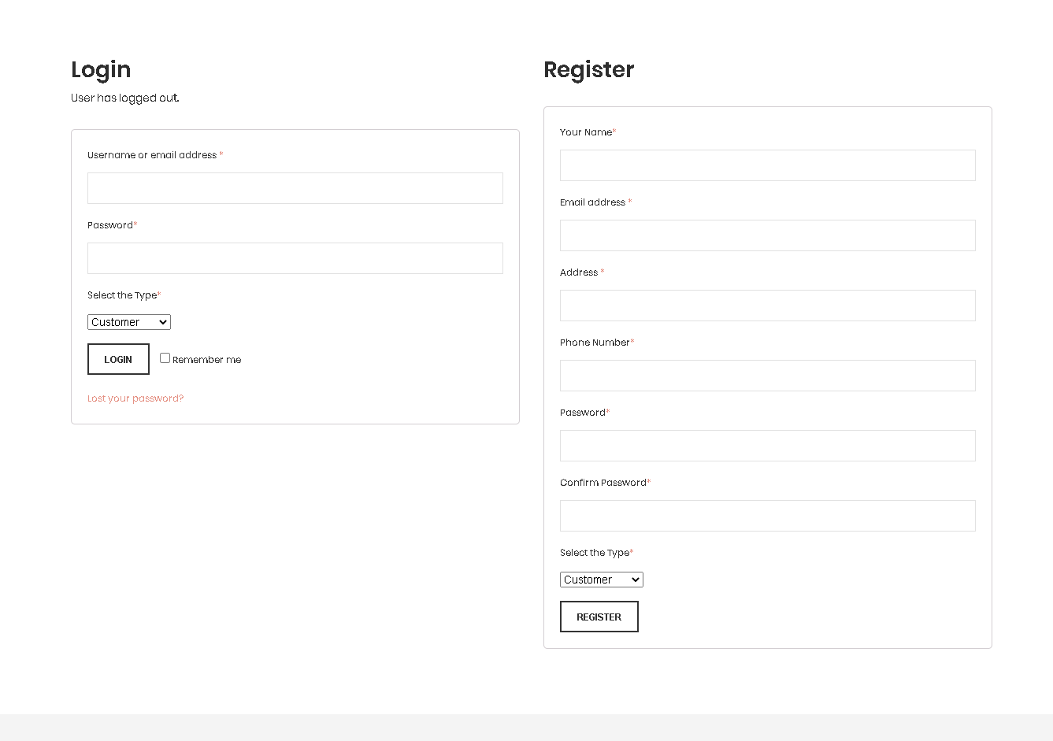

1. OTP and password sent in customer account. After pasting the valid password in required filled customer can log in again.

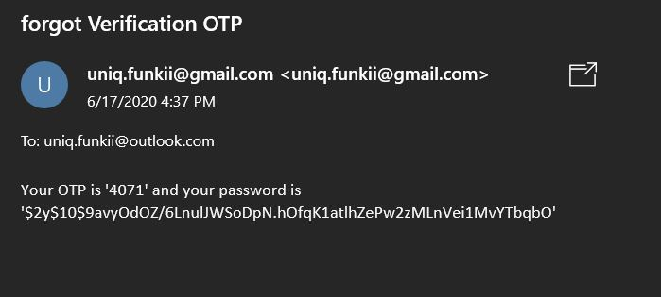

1. After login in customer can visit the home page and shop the products. Click on products to view products page.

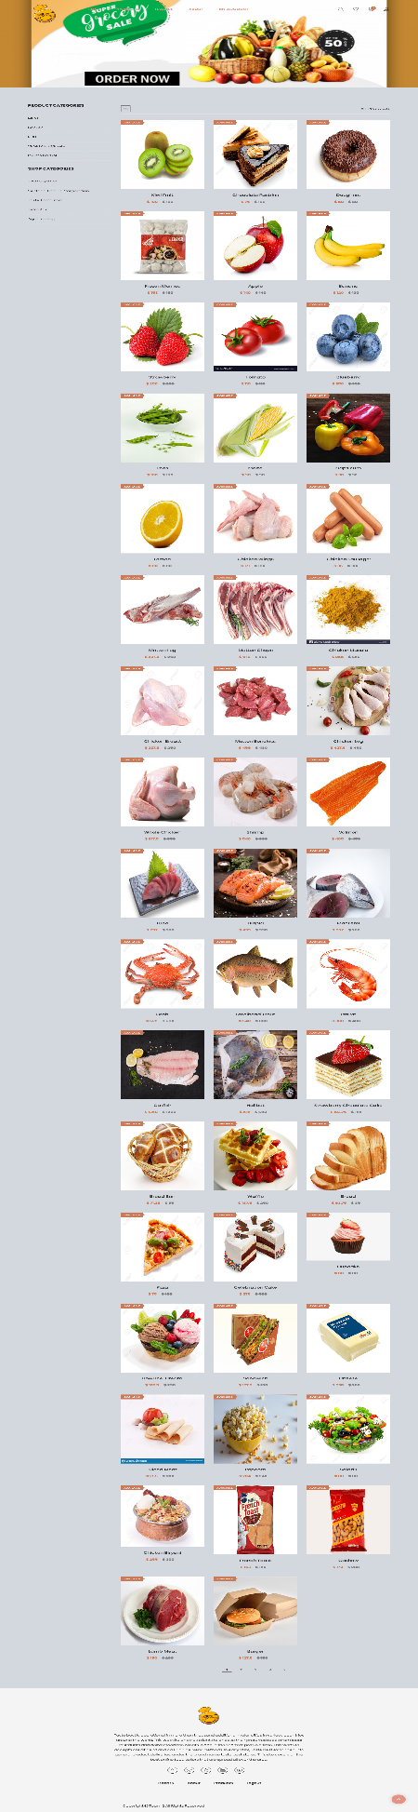

1. Customer can search for the specific product from search bar.

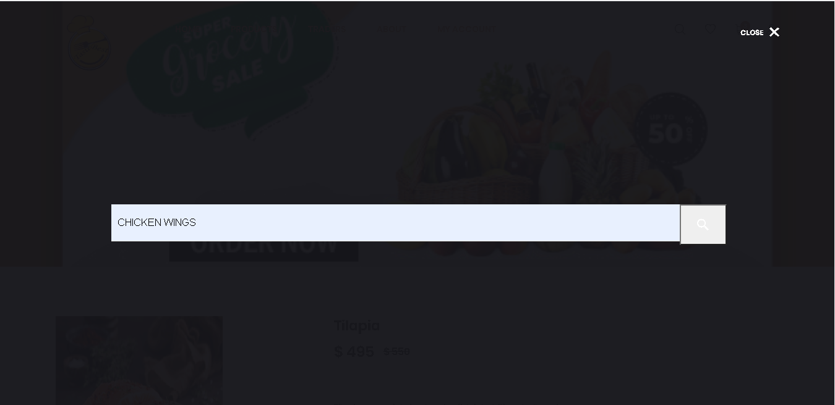

1. Customer can now shop products through product categories and shop categories in product page.

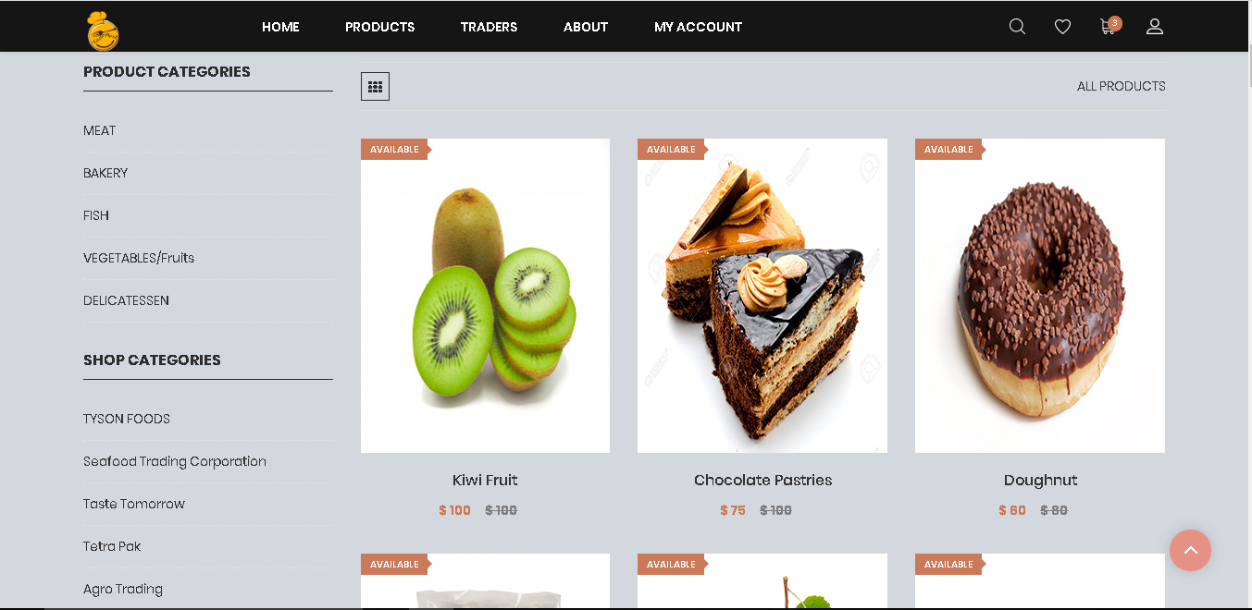

1. When customer clicks on the meat page products are sorted by meat items and this process applies to all the product categories available.

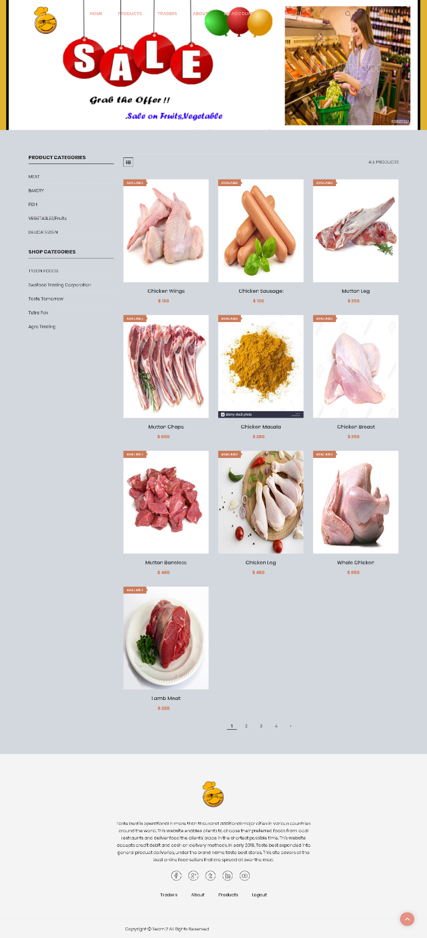

1. Similarly, customer can buy products by clicking on shop categories where products are sorted according to shops. When Customer clicks on Seafood Trading Corperation and particular products of this shop are shown.

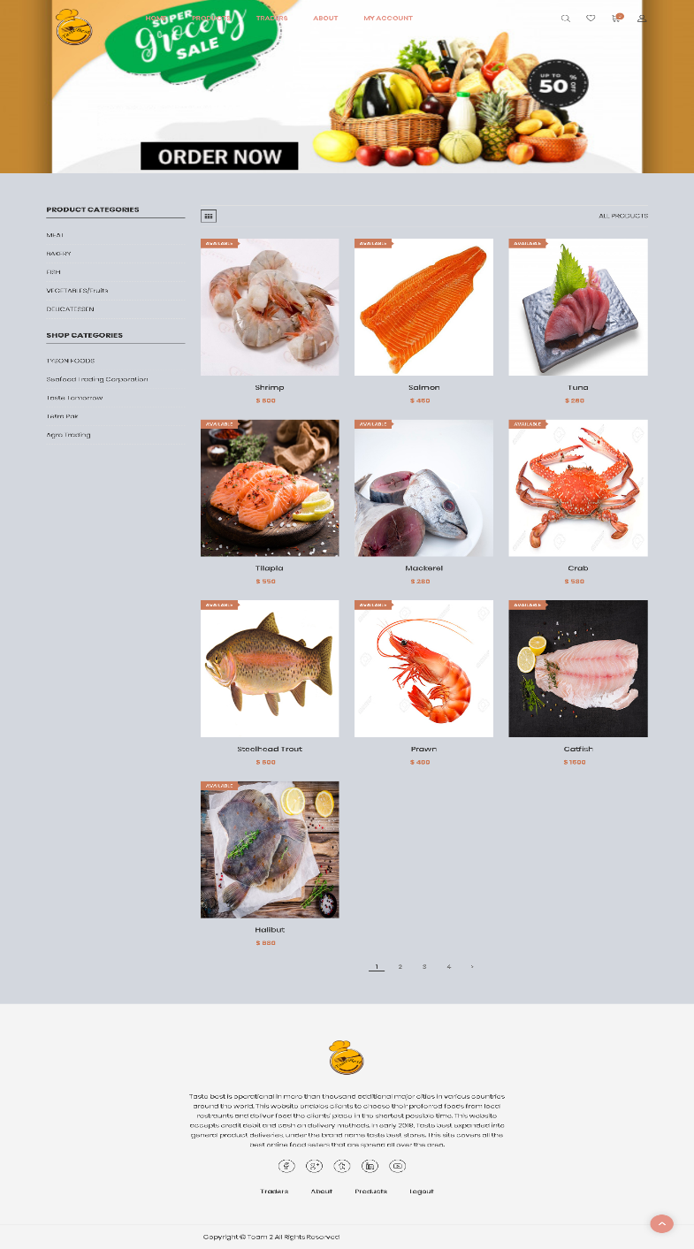

1. 11. Customer can add products in wishlist and to the cart by clicking icons below the products.

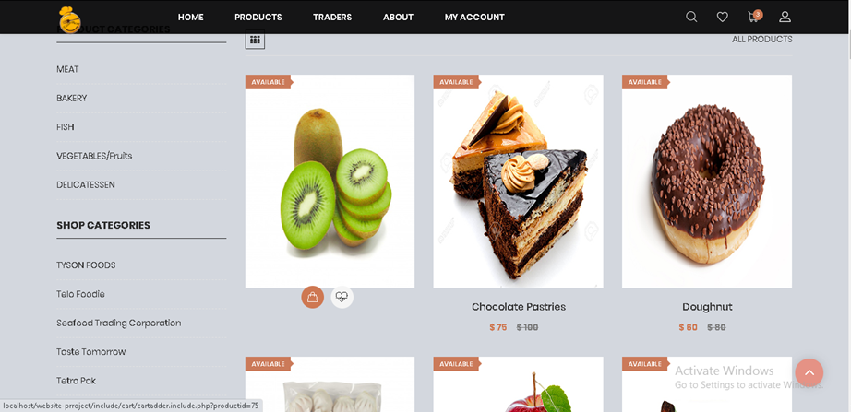

1. When wishlist icon is clicked by customer in navigation bar wishlist page along with product description appears.

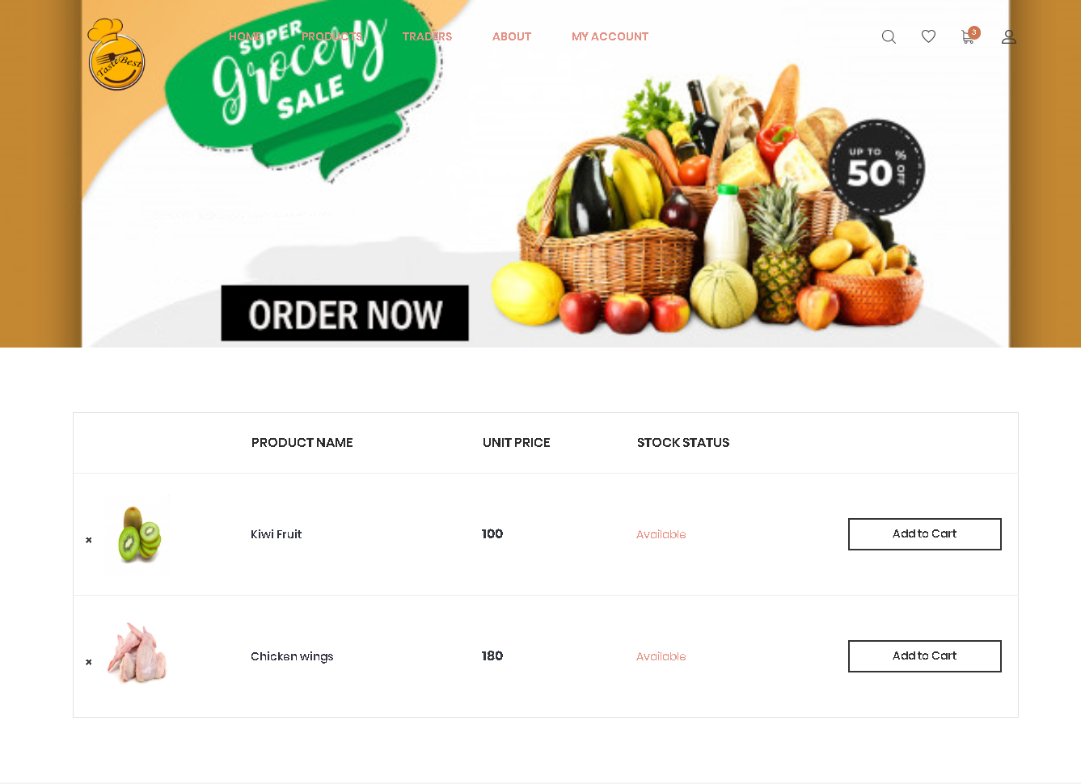

1. When customer clicks in specific product, price detail with the product information along with add to cart button are shown. 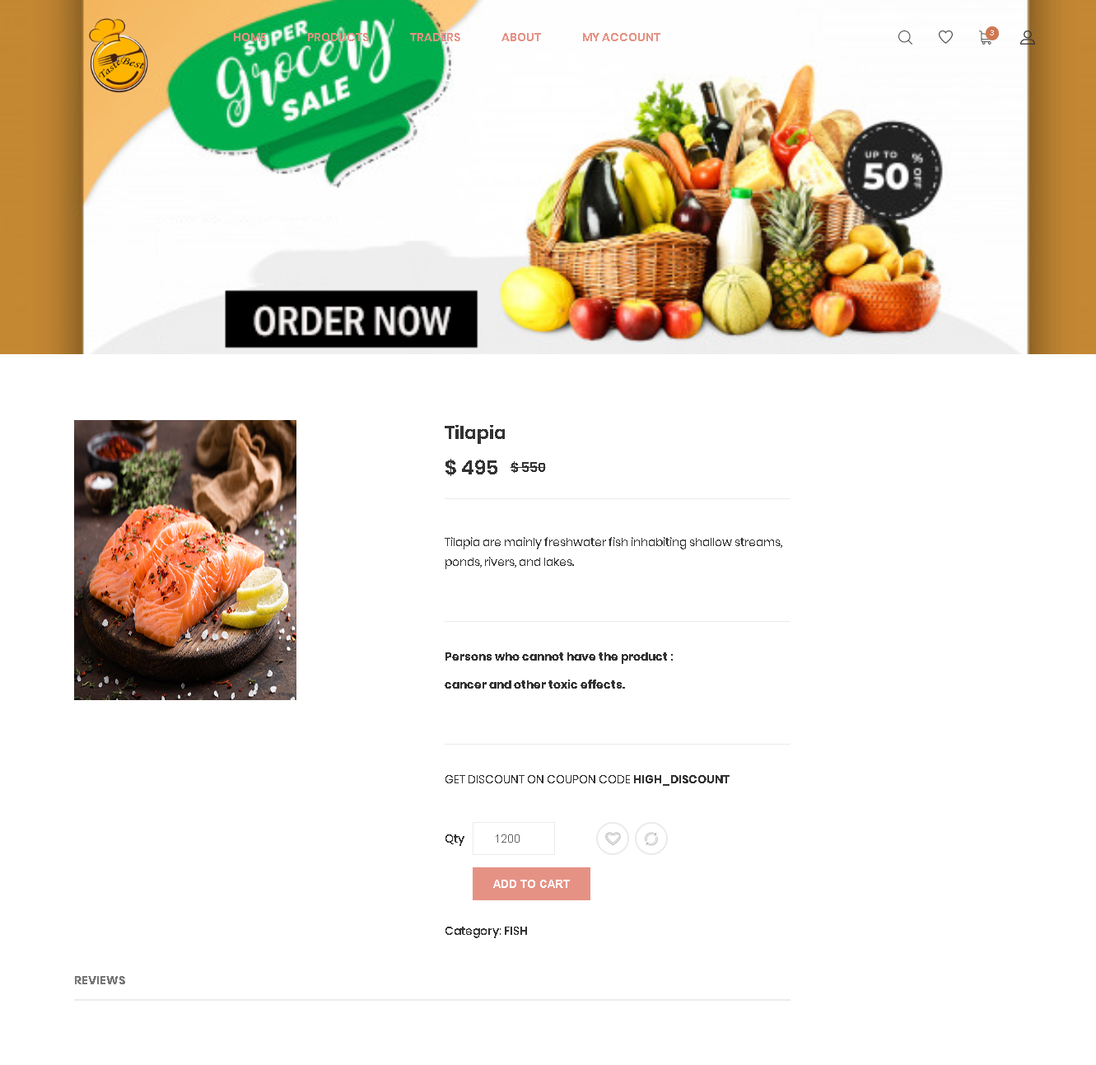
2. Customer can give reviews and ratings on products by clicking review where rating and summary of products are given and clicking on submit button reviews and rating will be stored.

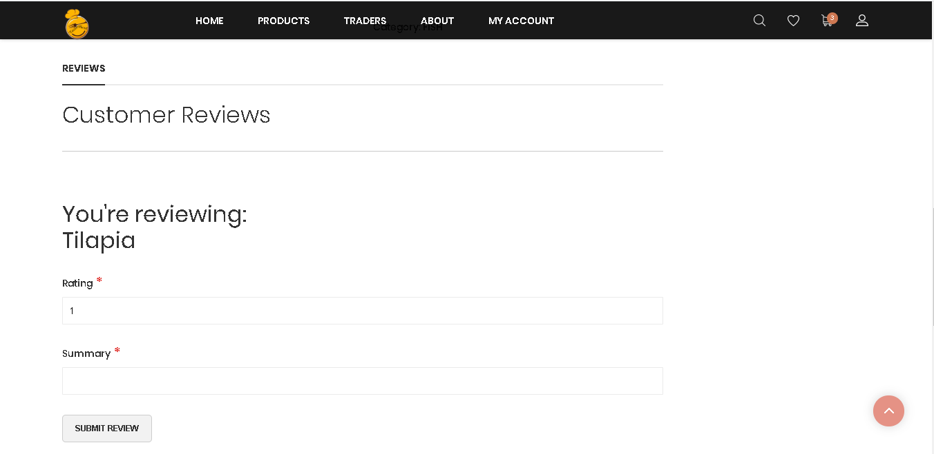

1. When customer clicks on add to cart button then add to cart page will pop up with all the product information, coupon code, discount added and grand total price.

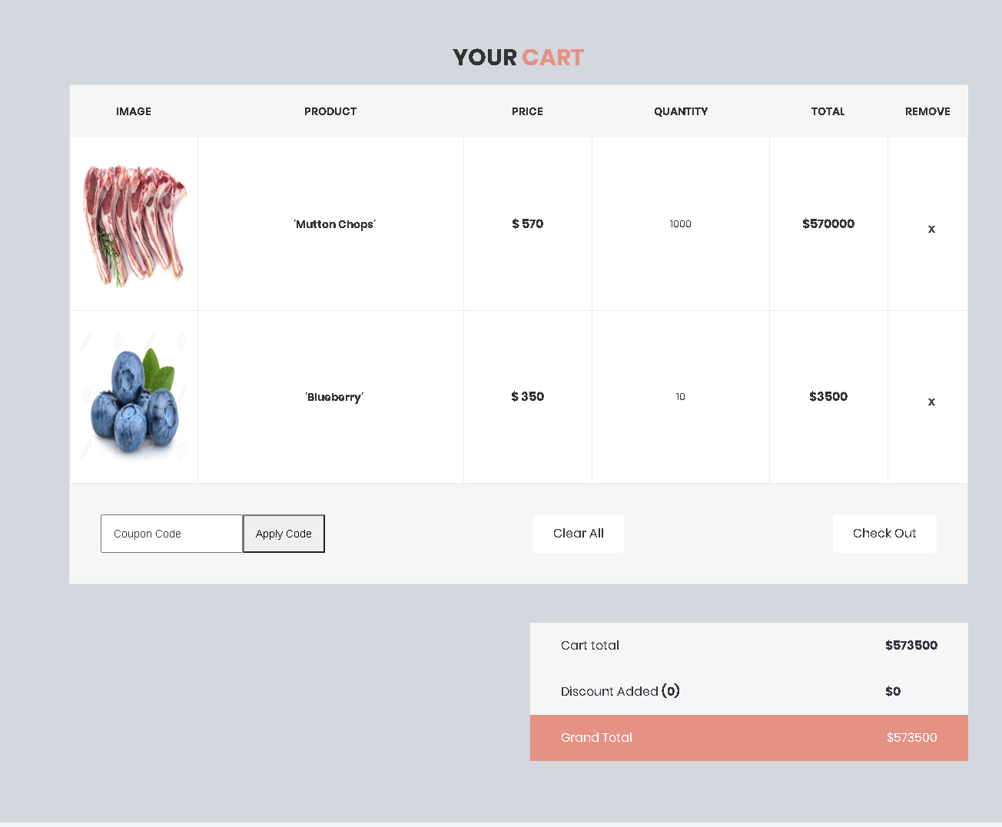

1. By clicking in checkout button customer will proceed to the next step where customer will place order by filling username, your message and collection slot field. 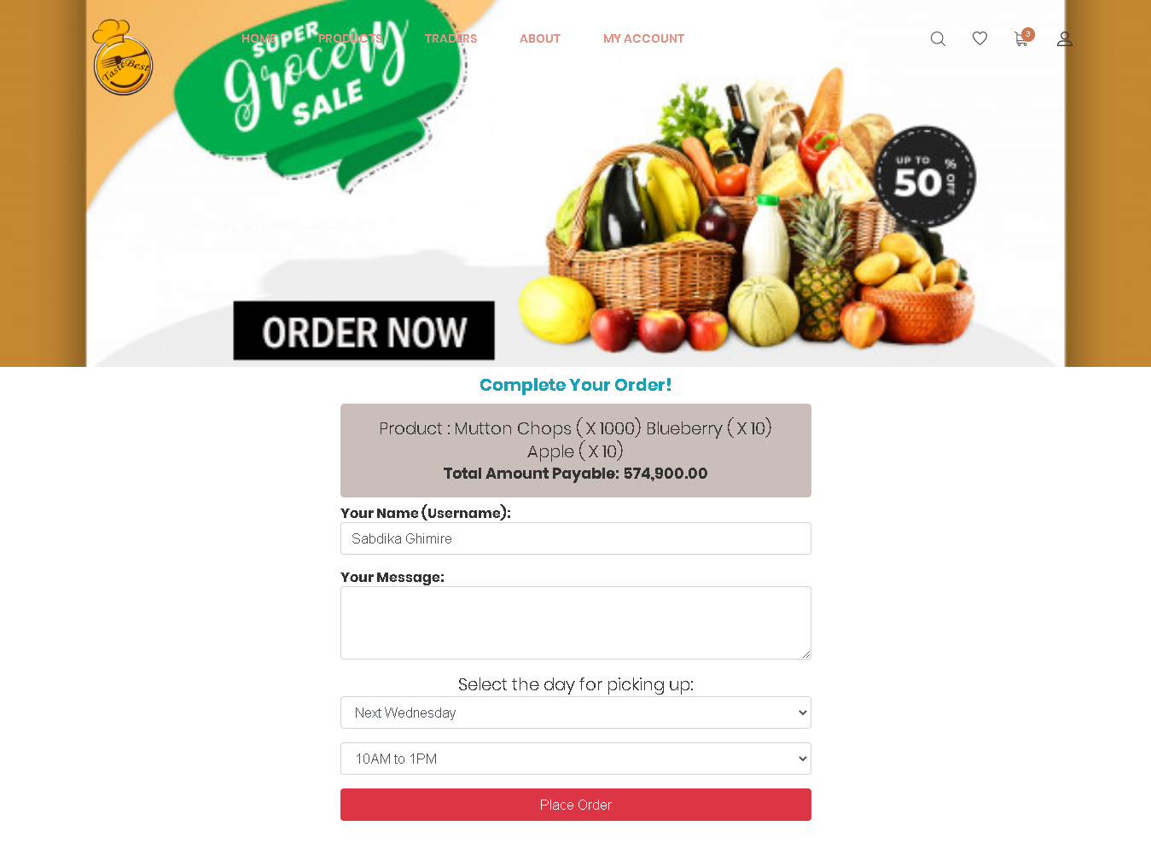
2. By clicking on PayPal logo customers are requested for payment procedure where method of payment is PayPal sandbox.

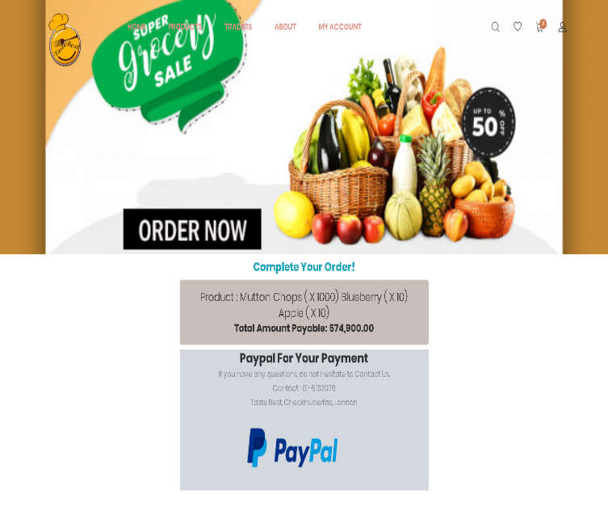

1. Now the PayPal will show the details of your order, card credential and shipment address and method of payment. Receipt will form and after clicking on pay now your payment will be completed.

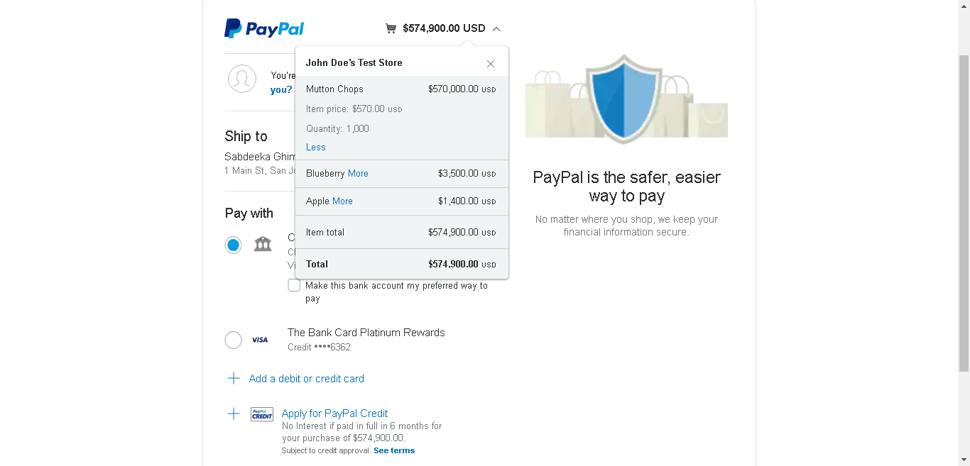

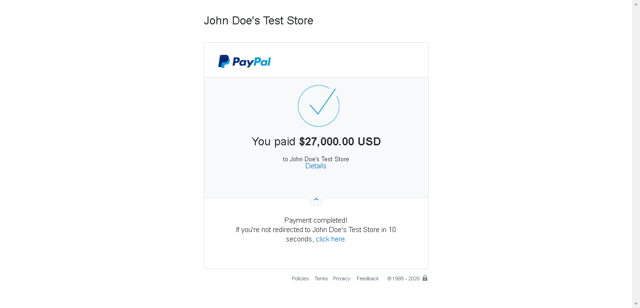

1. After payment is completed customer cart will be empty because product is placed for order and invoice with every information will be sent to customer account.

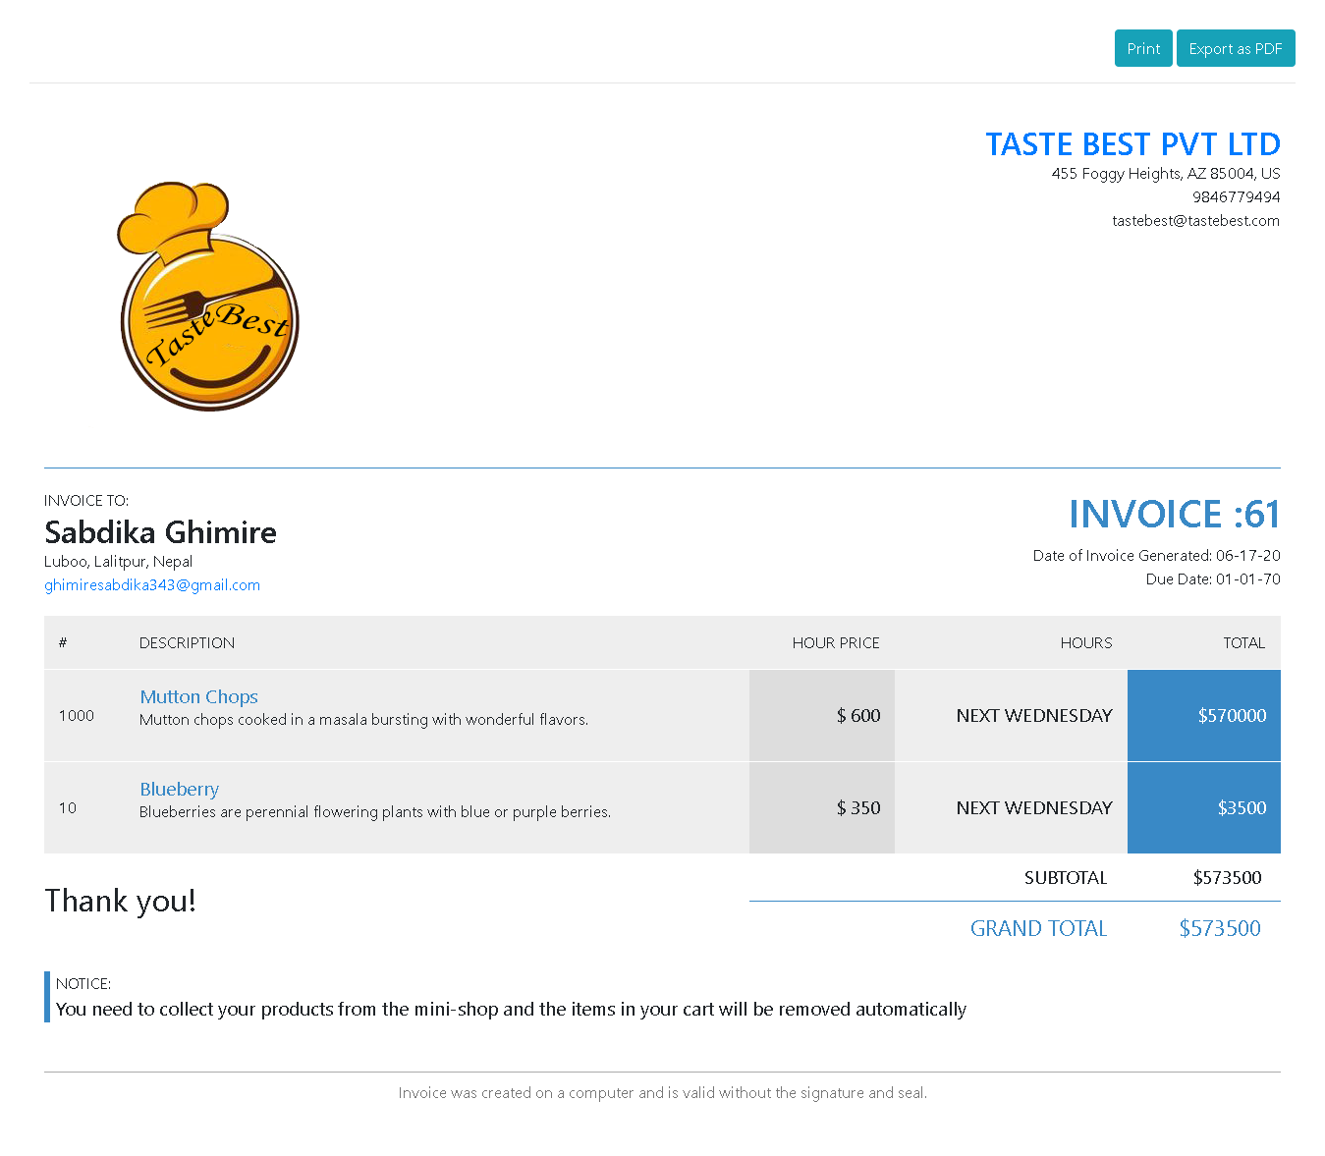

1. Customer can view traders and their shop information by clicking traders in navigation bar and will show all the details.

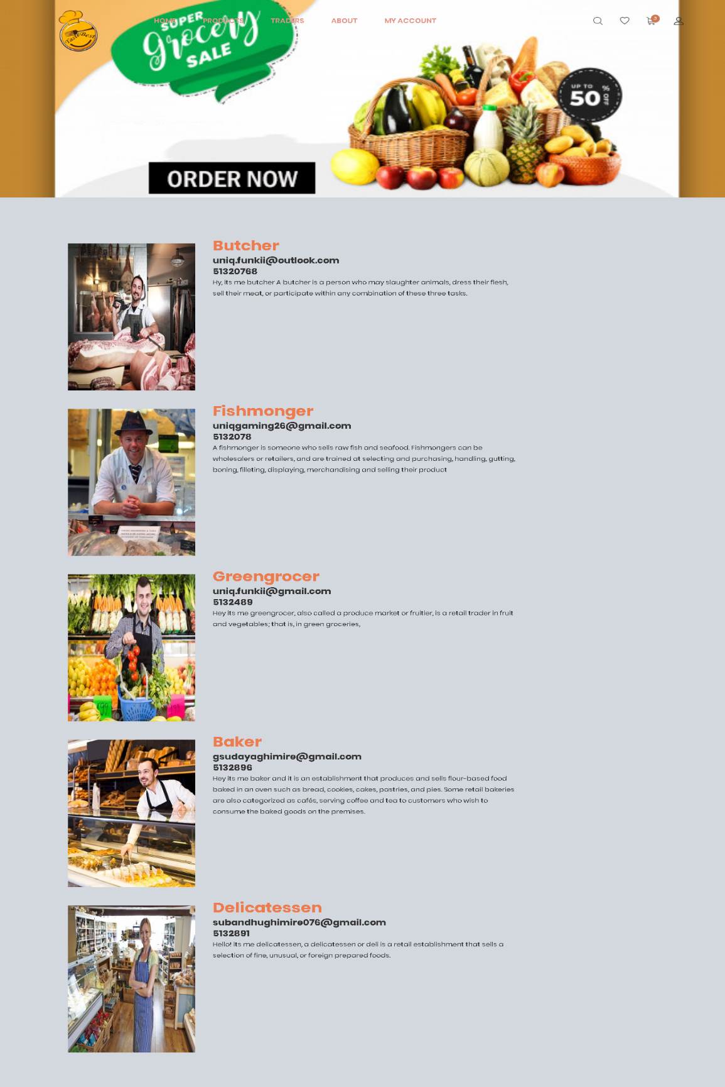

1. Customer can also view about page by clicking on about in navigation bar where all the information about our site, team members and advantage of online shopping are mentioned.

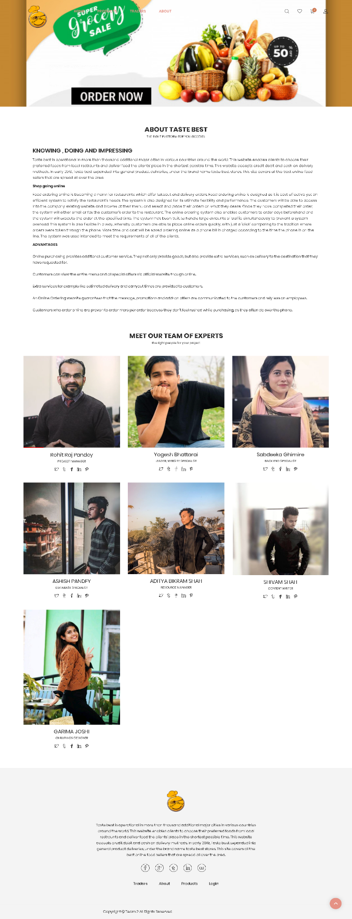

1. Customer can access my account page from navigation bar where they will be able to edit their profile by clicking on edit account button.

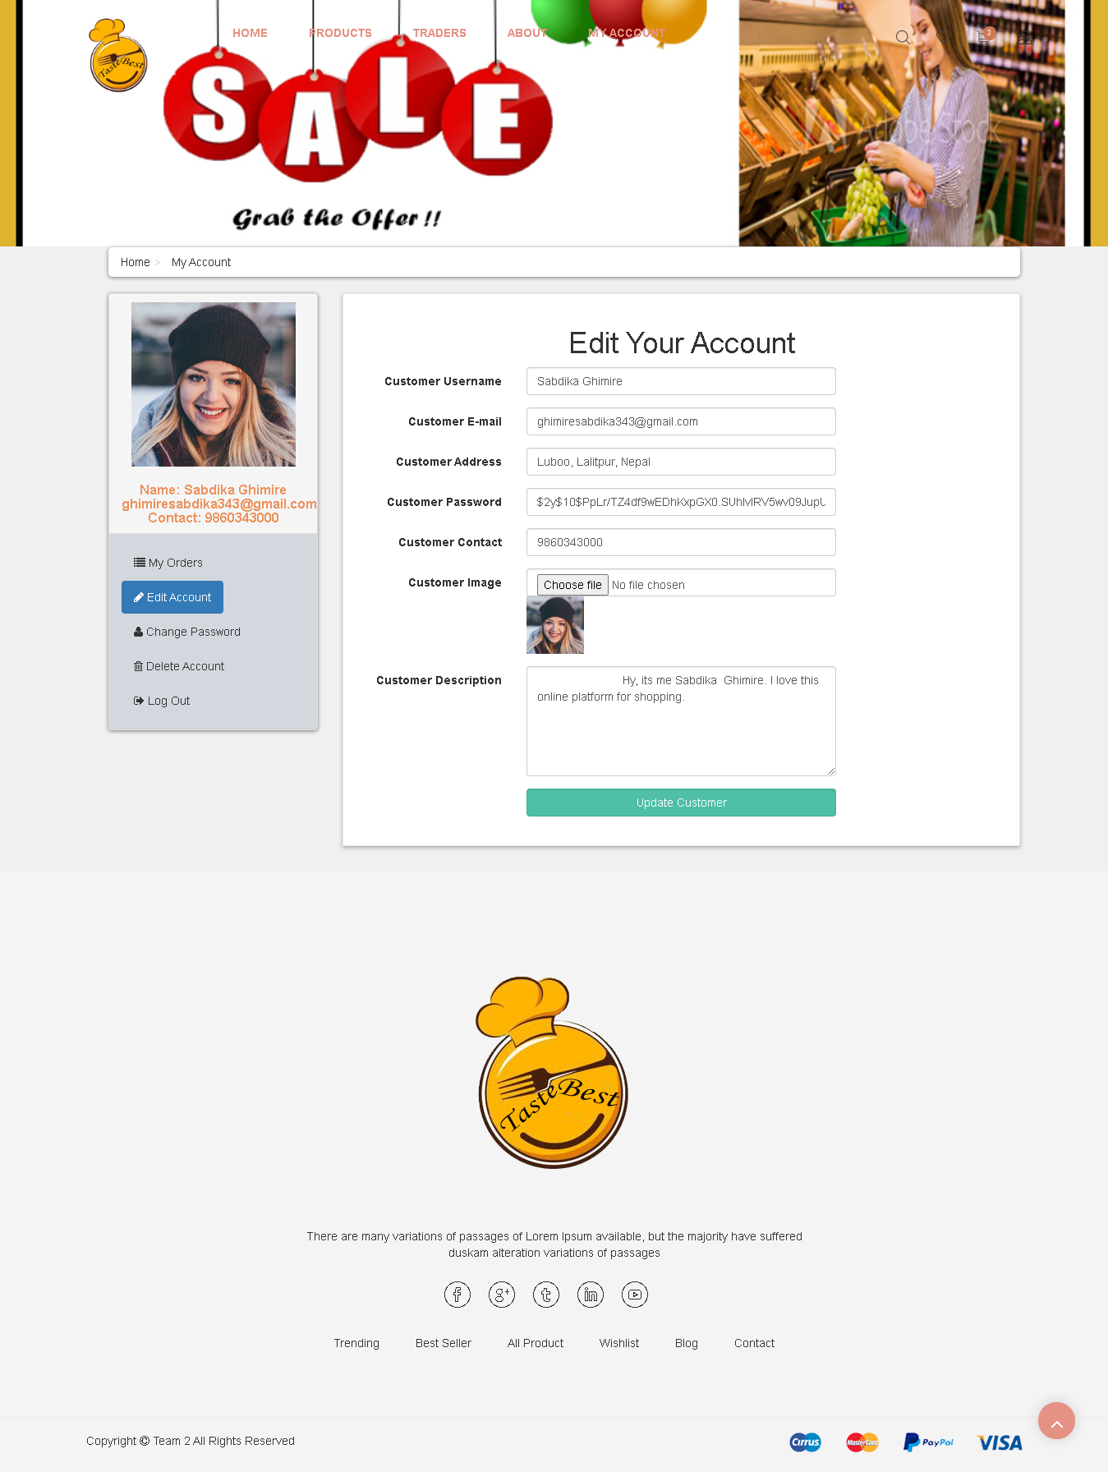

1. Similarly, clicking on my orders customer will able to see detail of their recent placed orders from where customer can access invoice by clicking on view invoice button.

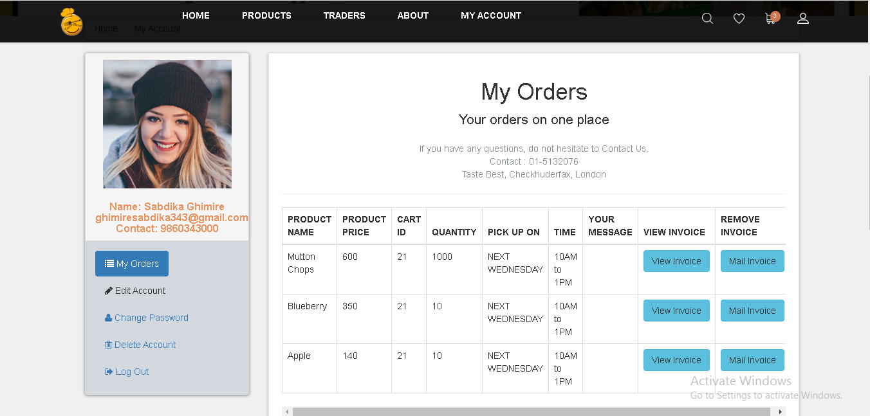

1. Customer also have access to deactivate their account from my account page by clicking on deactivate account.

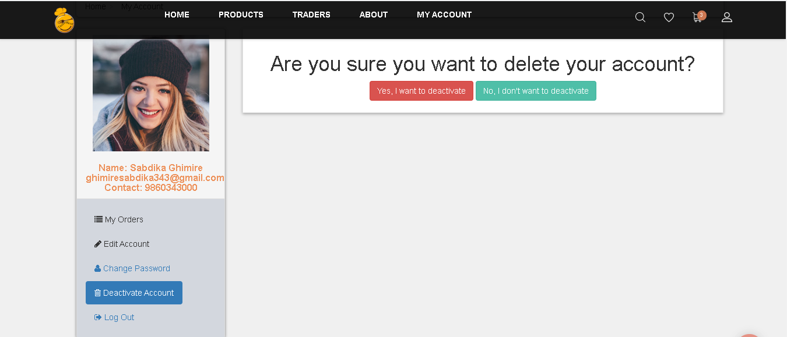

1. After clicking on ‘yes, I want to deactivate’ button customer will be redirected to log in page. As the account is deactivated customer cannot access and so in order to activate again ‘ACTIVATE_AGAIN’ should be keep in the field and clicking on activate button will again activate the customer account.

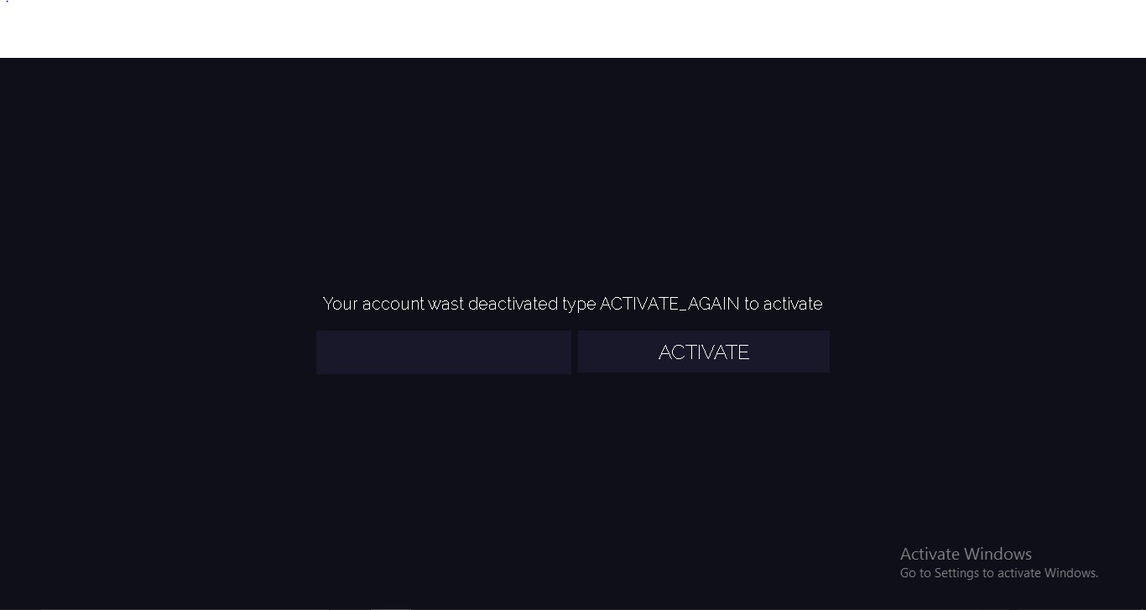

1. Clicking in Log Out in my account page customer will proceed to the next page where red ‘Logout’ button will help customer to log out and customer can only view login and registration page.

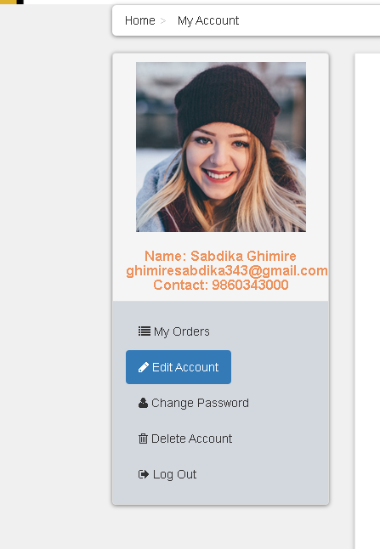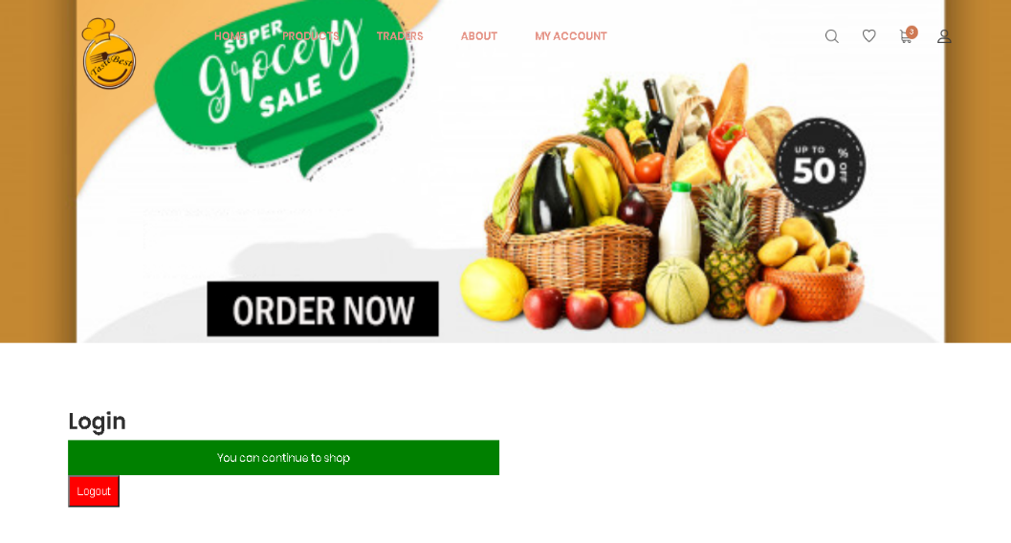

wdai

adadadadadada

sssd

D

adsdadadsad

s